- Process Overview
  - Purpose
This document provides a general overview of how to operate the Axygen/PlateMax Semi-Automated Plate Sealer. Additionally, it includes a brief introduction to the physical components, digital interface, cleaning procedure and general troubleshooting guidelines.
  - Scope
This procedure applies to the Axygen/PlateMax Semi-Automated Plate Sealer at LGC Bio Search Technologies, Inc.
- Definitions/Acronyms
  - Seal Temp – Refers to the temperature used in plate sealing process.
  - Seal Time – Refers to how long the sealing process takes.
  - Heatin Platen – A flat plate located in the plate sealers that helps to adhere seal to sample plates.
  - Sealing Frame – A metal plate that helps to ensure proper positioning of thermal seals.
- References/Associated Documents
  - Axygen PlateMax Instruction Manual
- Procedure
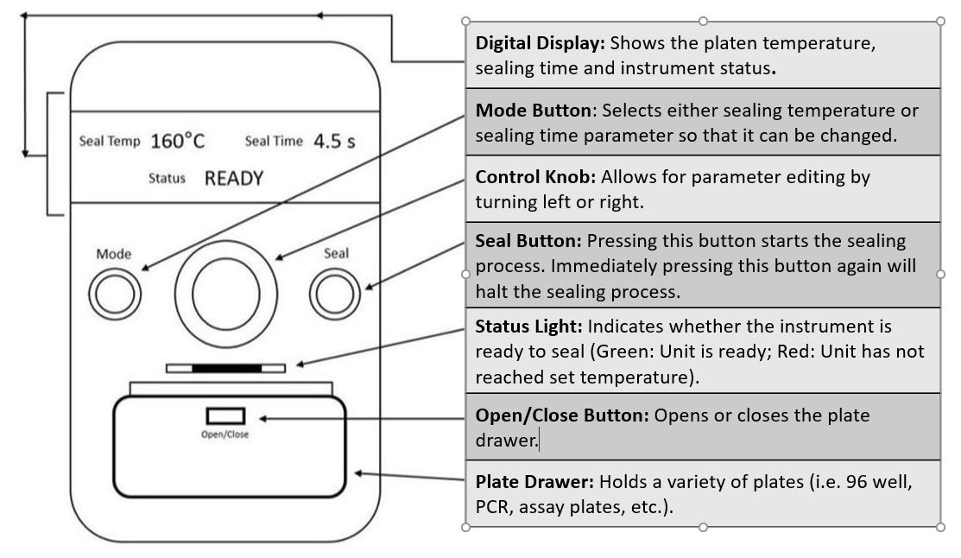
  - Physical Unit / Component Layout
Figure 1. Axygen Plate Sealer Diagram
    - Digital Display
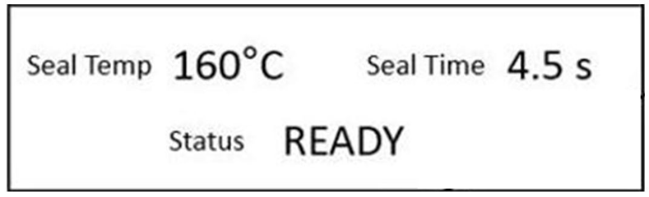
Figure 2. Axygen Plate Sealer Digital Display

Seal Temp: Indicates sealing platen temperature (recommended setting: 165°C).
Seal Time: Displays the time it takes to seal plate (recommended setting: 4.5s).
Status: Displays, heating, cooling, ready or error messages.
Figure 2 Key
  - Operating the Axygen Plate Sealer
    - Setting the temperature
      - Press the MODE button until “seal temp” text starts flashing on the digital display. Turn the control knob left or right to set the plate sealer to the desired temperature. Once the desired temperature is set, pressing the control knob or waiting ten seconds will set the temperature. If the set temperature is higher than the ambient temperature of the plate sealer, then the word “heating” will pop up in the status section of the digital display. If the temperature is set lower than the ambient temperature of the plate sealer, then the word “cooling” will appear. The status indicator will also flash red until the plate sealer has reached the desired temperature. Once the plate sealer has reached the desired temperature, the status indicator will be steady green.
    - Setting the Seal Time
      - Press the MODE button until “seal time” text flashes. Use the control knob to adjust the plate sealer to the desired seal time. Press the control knob or wait ten seconds to set the desired seal time.
    - Sealing a Plate
      - Before sealing a plate, make sure that the sealing temperature is set to 165°C and sealing time is set to 4.5 seconds.
      - Insert plate adapter for specialty plates if necessary (i.e. PCR, assay plates).
      - Place plate in the motorized drawer.
      - Place seal on top of plate and place sealing frame on top of the seal. Make sure that the seal is placed with the sealing side facing the plate. If the sealing side faces the heating platen, it will have to be cleaned (refer to section 4.2.4).
      - Press the Seal Button once the status light is solid green (The drawer will close, seal and open back up automatically).
      - Remove the sealing frame and sealed plate.
      - Allow the plate to cool before storing it in a refrigerator.
    - Cleaning the Axygen Plate Sealer
      - If a seal ever gets stuck to the heating platen, it must be removed from the plate sealer and cleaned.
      - The plate sealer must be cooled for at least 1 hour before removing the heat platen (unit should be turned off and unplugged).
      - Remove the screw of the access door (on the side of the plate sealer) using a Philips head screwdriver and remove the platen.
      - The plate should only be cleaned using a flat plastic blade. Using a metal tool, can result in permanent damage to the platen. Alcohol can be used to aid the cleaning process.
      - Replace the cleaned platen and secure the access door with the screw.

  - Troubleshooting
Possible Problems | Cause and Solution
Plates are not sealing correctly (i.e. incomplete sealing, not sealing at all) | Incorrect or incomplete sealing of plates can be due to a variety of factors including the sealing temperature being too low, inadequate sealing time or the plate not sitting correctly in the motorized drawer. Be sure to check the sealing film’s manufacturer guidelines for recommended settings.
Sealing film curls or moves out of position before sealing can occur. | This can be due to temperature difference or electrostatic charge affecting the seal. The sealing frame can be used to help secure the sealing film in place.
Sealing film sticks to the heating platen. | Make sure that the sealing side of the seal is facing the plate. If the sealing film sticks to the heating platen regularly, there might be something else stuck to the platen. Consult section  4.2.4 for platen cleaning procedure.
Figure 3. Troubleshooting Guidelines
- Summary of Changes
Revision | Description of Change | CRR No.
1.0 | Initial Release of Document | 2021-0383

